DRAFT

CAPE ELIZABETH TOWN COUNCIL MINUTES

Regular Meeting # 6-2011
Cape Elizabeth Town Hall

Monday, April 11, 2011

Roll Call by the Town Clerk Present Absent
David S. Sherman, Jr., Chair Term Expires 12/2011 X dsherman@dwmlaw.com
Frank J. Governali Term Expires 12/2013 X frank.governali@capeelizabeth.org
Caitlin R. Jordan Term Expires 12/2013 X caitlin.jordan@capeelizabeth.org
Sara W. Lennon Term Expires 12/2012 X slennon@maine.rr.com
Jessica L. Sullivan Term Expires 12/2012 X jsullivan08@maine.rr.com
Anne E. Swift-Kayatta Term Expires 12/2011 X aeskay@maine.rr.com
James T. Walsh Term Expires 12/2012 X james.walsh@capeelizabeth.org
Michael K. McGovern, Town Manager X
Debra M. Lane, Town Clerk X

The Pledge of Allegiance to the Flag

Town Council Reports and Correspondence

Appointments Committee Chair Jessica Sullivan reported a vacancy on the Thomas Memorial Library Trustees, an unexpired term until 12/31/2012. Interested residents may apply online or obtain an application from the Town Clerk. The deadline to file applications is Wednesday, April 20, 2011.

Citizen Opportunity for Discussion of Items Not on the Agenda None

Town Manager’s Report None

Review of Minutes of Meetings Held March 14, and March 21, 2011

Moved by Anne E. Swift-Kayatta and Seconded by Caitlin R. Jordan
Ordered the Cape Elizabeth Town Council approves the minutes of meeting #4-2011 held March 14, 2011 and special meeting #5-2011 held March 21, 2011 as presented.
(7 yes) (0 no)

Item #62-2011 Proposed Fiscal Year 2012 Budget

Public Comment Period on the Fiscal Year 2012 Budget

Intro - Finance Chair Sara Lennon

7:36 p.m.
Chair Sherman invited public comments on the fiscal year 2012 budget.

Dan Fishbein, 6 Hunts Point Road
Mr. Fishbein congratulated the Town Council and School Board on the proposed budgets. He is in favor of the budget as presented.

Page 2 Town Council Minutes
April 11, 2011

Jana Zimmerman, 81 Oakhurst Road
Ms. Zimmerman supports the school budget. She commended the school board and superintendent on the process; “solution based.”

7:39 p.m.
After hearing no further public comments Chair Sherman asked for a motion.

Moved by Sara W. Lennon and Seconded by James T. Walsh
Ordered the Cape Elizabeth Town Council approves the recommendation of the Town Council Finance Committee to set a public hearing for Monday, April 25, 2011 at 7:30 p.m. at the Cape Elizabeth Town Hall on the proposed general fund budget for FY 2012. Actual tax rates are set by the assessor based upon the adopted budget. Amounts may be changed following the public hearing.
(7 yes) (0 no)

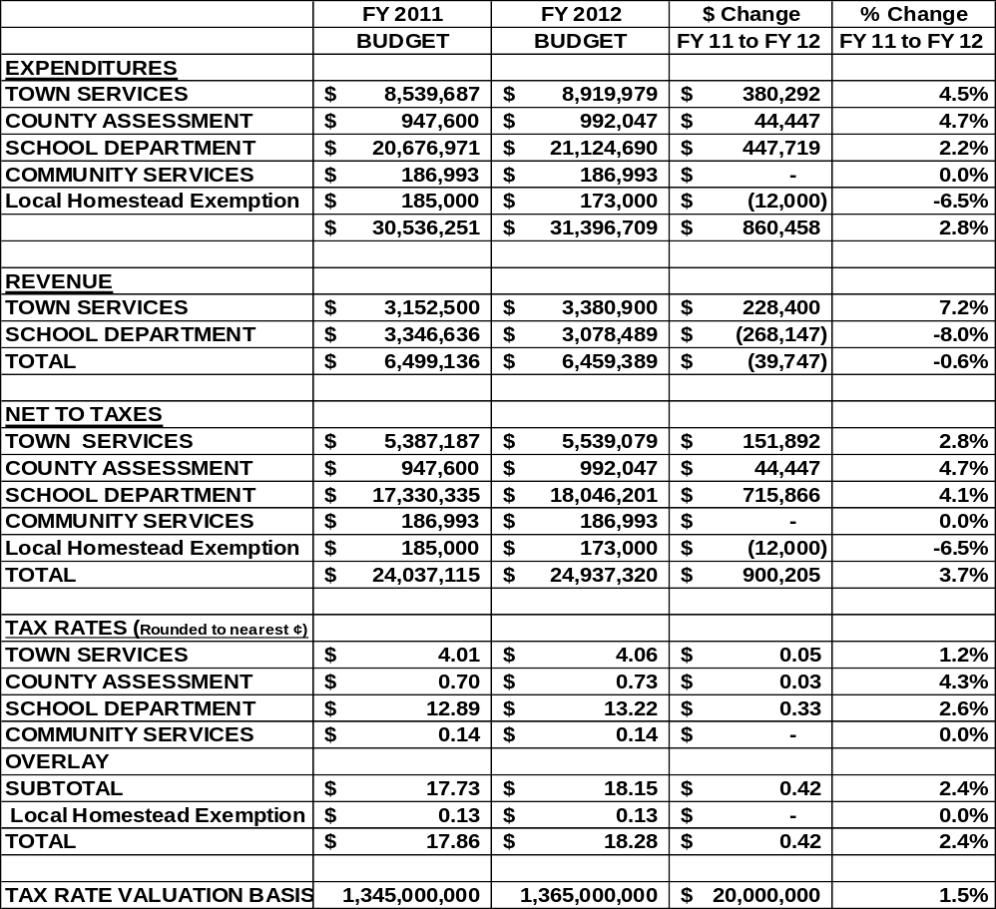

Item# 63-2011 Proposed Fiscal Year 2012 Special Funds Budgets

Moved by Sara W. Lennon and Seconded by James T. Walsh
Ordered the Cape Elizabeth Town Council approves the recommendation of the Town Council Finance Committee to set a public hearing for Monday, April 25, 2011 at 7:30 p.m. at the Cape Elizabeth Town Hall on the proposed special funds budgets for FY 2012. Amounts may be changed following the public hearing.
(7 yes) (0 no)
Page 3 Town Council Minutes
April 11, 2011

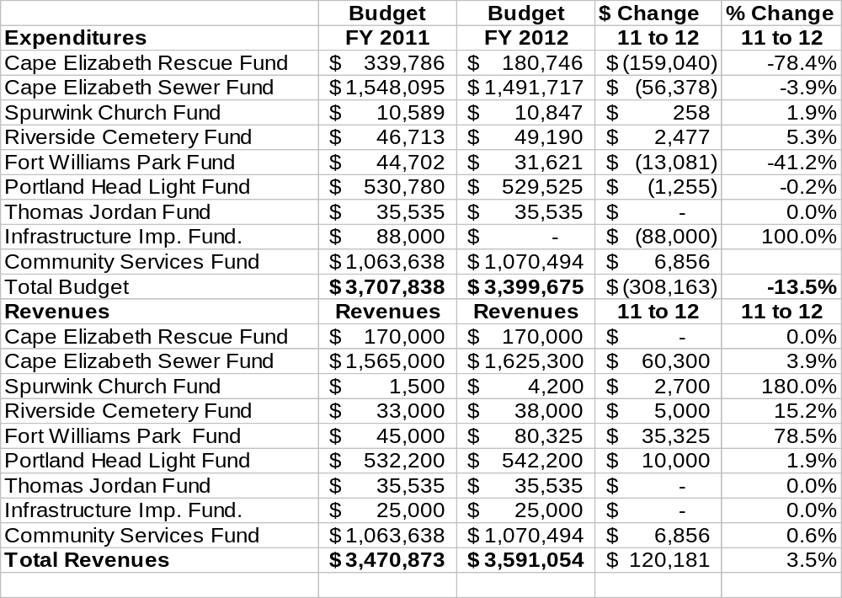

Item# 64-2011 Rooster Review Request

Intro - Jim Huebener, Planning Board

Moved by Jessica L. Sullivan and Seconded by Sara W. Lennon
Ordered the Cape Elizabeth Town Council acknowledges receipt of the Planning Board report
that recommends the issue of roosters not be dealt with within the Zoning Ordinance and refers
the issue to the Ordinance Committee.
(6 yes) (1 no Councilor Jordan)

Item# 65-2011 Fort William Park Group Use Request
USCG Change of Command Ceremony

Present – Lt. K.M. Beck, U.S. Coast Guard

Moved by Anne E. Swift-Kayatta and Seconded by Jessica L. Sullivan
Ordered the Cape Elizabeth Town Council approves the recommendation of the Fort Williams
Advisory Commission for the United States Coast Guard Sector New England to use the green
in Fort Williams Park next to Portland Head Light for a change of command ceremony with a
reception to follow on Friday, June 24, 2011 as presented. The approval includes the request to
serve beer and wine at the noon reception.
(7 yes) (0 no)

Page 4 Town Council Minutes
April 11, 2011

Item# 66-2011 Fort William Park Group Use Request
Wedding Reception

Moved by James T. Walsh and Seconded by Anne E. Swift-Kayatta
Ordered the Cape Elizabeth Town Council accepts the recusal of Councilor Jordan from
discussion and voting on Item #66-2011. Councilor Jordan is the sister of Tucker Jordan.
(6 yes) (0 no)

Intro – Tucker Jordan, Applicant
Bill Nickerson, Fort Williams Advisory Commission

Present – Mark Tibbetts, Representative of the tent company

Chair Sherman recognized Mr. Huebener for public comments.

Jim Huebener, 13 Kettle Cove Road
Mr. Huebener has performed wedding ceremonies in Fort Williams Park and wanted to clarify
that wedding ceremonies are allowed with permission, if required.

Moved by Jessica L. Sullivan and Seconded by Anne E. Swift-Kayatta
Ordered the Cape Elizabeth Town Council denies the request of Tucker Jordan the use of the
green in Fort Williams Park next to Portland Head Light for a wedding reception on Saturday,
June 4, 2011.
(4 yes) (2 No Councilor Governali and Councilor Lennon)

Item# 67-2011 Acceptance of Drainage Easement
1175 Shore Road Nominee Trust

Moved by Jessica L. Sullivan and Seconded by Sara W. Lennon
Ordered the Cape Elizabeth Town Council accepts with appreciation to the Trustees an
easement from the 1175 Shore Road Nominee Trust for a drainage easement at 1175 Shore
Road as requested by the Town as presented.
(7 yes) (0 no)

Page 7 Town Council Minutes
April 11, 2011

Item # 68-2011 Warrant for School Budget Validation Vote

Moved by Jessica L. Sullivan and Seconded by James T. Walsh
Ordered the Cape Elizabeth Town Council approves the warrant for the May 10, 2011 school budget validation vote as presented.
(7 yes) (0 no)

TOWN OF CAPE ELIZABETH
SCHOOL BUDGET VALIDATION REFERENDUM
WARRANT
TUESDAY, MAY 10, 2011

County of Cumberland, ss.

To Neil R. Williams, a constable of Cape Elizabeth. You are hereby directed to notify the voters of Cape Elizabeth of the election described in the warrant.

School Budget Validation Referendum

YES Do you favor approving the Town of Cape Elizabeth school budget for the upcoming school
NO year that was adopted at the latest school budget meeting of the Town Council?

The following is a non-binding expression of opinion for the consideration of the School Board and Town Council.

I find the school budget adopted at the April 25, 2011 Town Council’s school budget meeting to be:

TOO HIGH
ACCEPTABLE
TOO LOW

Election to be held on Tuesday, May 10, 2011, at the Cape Elizabeth High School Gymnasium.

Polls open at 7:00 a.m. and Close at 8:00 p.m.

Absentee Ballot Processing:

Absentee ballots will be processed on Election Day, on the hour every hour until close, beginning at 7:00 a.m. The Cape Elizabeth Town Democratic Committee, the Cape Elizabeth Town Republican Committee and State Green Independent Party have also been notified, in writing, of the absentee ballot process.

The Registrar of Voters is available to accept new registrations and corrections to the voter list on Election Day at the polls and prior to Election Day at Town Hall, 320 Ocean House Road. Town Hall is open Mondays 7:30 a.m. - 5:00 p.m. and Tuesday - Friday, 7:30 a.m. - 4:00 p.m. Proof of residency and identity is required.

______________________ _______________________
______________________ _______________________
______________________ _______________________
_____________________________

Municipal Officers of Cape Elizabeth, Maine
Dated at Cape Elizabeth this 11th day of April 2011.

A true copy. Attest: ____________________________ Constable Attest: _____________________________ Town Clerk

The warrant and specimen ballots shall be posted at least 7 days prior to the election.

Page 8 Town Council Minutes
April 11, 2011

Item # 69-2011 Quit Claim Deed
971 Shore Road

Moved by Anne E. Swift-Kayatta and Seconded by Sara W. Lennon
Ordered the Cape Elizabeth Town Council authorizes the Town Manager to sign a quit-claim deed to the Estate of Virginia Wieland for property at 971 Shore Road, Map U06 Lot 094.
(7 yes) (0 no)

Item # 70-2011 Riverside Cemetery Trustees 2011 Work Plan

Moved by Sara W. Lennon and Seconded by Caitlin R. Jordan
Ordered the Cape Elizabeth Town Council acknowledges receipt of the Riverside Memorial Cemetery Trustees 2011 Work Plan as presented.
(7 yes) (0 no)

Riverside Memorial Cemetery Trustees
2011 Work Plan

The goal of the Riverside Memorial Cemetery Trustees is to maintain the integrity of the Riverside Memorial Cemetery through upholding the rules and regulations which have been developed over many years.

The Trustees will hear the needs and requests of Cape Elizabeth residents, their families and non-residents. Requests to purchase lots and approve the buy back of lots are based on the rules and past decisions and precedents set throughout many years.

In May 1993 the Master Plan of the Riverside Memorial Cemetery was adopted. The document has guided the Trustees and the town in developing the cemetery through 5 phases. Before the town embarks on the 5th and final phase, the Trustees would like to update the plan. The cost and scope of work will be reviewed with Mohr & Seredin, the original authors of the plan, before the update is approved.

The Trustees will work with town staff as the update of the Master Plan is developed particularly as it relates to future years budget, lots prices, and rules and regulations.

The Trustees look forward to a productive and exciting year as they look carefully to the future of the Riverside Memorial Cemetery.

Citizen Opportunity for Discussion of Items Not on the Agenda None

Item # 71-2011 Executive Session Request

Moved by Anne E. Swift-Kayatta and Seconded by Sara W. Lennon
Ordered the Cape Elizabeth Town Council enters into executive session at 8:55 p.m., in conformance with 1MRSA §405 6 C and F, to discuss land acquisition/disposition issues and to review an application for an abatement of taxes due to hardship.
(7 yes) (0 no)

Councilor Lennon left at 9:59 p.m.

Moved by Anne E. Swift-Kayatta and Seconded by Jessica L. Sullivan
Ordered the Cape Elizabeth Town Council exits executive session and reenters public session at 10:02 p.m.
(6 yes) (0 no)

Moved by Anne E. Swift-Kayatta and Seconded by Jessica L. Sullivan
Ordered the Cape Elizabeth Town Council grants the request for an abatement of real estate taxes due to hardship in the amount of $3086.46.
(6 yes) (0 no)
Page 9 Town Council Minutes
April 11, 2011

Adjournment

Moved by James T. Walsh and Seconded by Anne E. Swift-Kayatta
Ordered the Cape Elizabeth Town Council adjourns at 10:05 p.m.
(6 yes) (0 no)

Respectfully Submitted,

______________________
Debra M. Lane, Town Clerk



